The Scottish Government  Chief Operating Officer Directorate | 
Dear Colleagues  IMPLEMENTATION OF SUB-NATIONAL PLANNING: CO-OPERATION AND PLANNING DIRECTIONS 2025  Purpose  - This letter accompanies the Co-operation and Planning Directions 2025 (the Directions), given under section 2(5) of the National Health Service (Scotland) Act 1978 (the 1978 Act), section 11(2) of the Patient Rights (Scotland) Act 2011 (the 2011 Act) and section 52(2) of the Public Bodies (Joint Working) (Scotland) Act 2014 (the 2014 Act), which come into force on 13 November 2025.  - This letter, including the Guidance attached at Annex A, has been developed to support the implementation of the Directions. A copy of the Directions is attached at Annex B.  - In order to comply with the Directions, Health Boards are encouraged to organise themselves in to two collaborative sub-national structures - Scotland East and Scotland West - through which they co-operate with each other in the planning and delivery of the objectives specified in the schedule to the Directions. These objectives deliver key aspects of the Health and Social Care Service Renewal Framework (2025–2035), the Population Health Framework, as well as wider ambitions related to public sector reform.  - Following discussion, Scotland East and Scotland West will each be supported by a Sub-National Planning and Delivery Committee (SPDC), whose membership is representative of the respective Health Boards.  - In anticipation of the Directions and the Guidance, Health Boards have also agreed that the SPDC for the East will be chaired by the Chair of NHS Lothian and for the West will be chaired by the Chair of NHS Greater Glasgow and Clyde, with the respective Chief Executives playing a lead role in establishing and co-ordinating the SPDCs and supporting them in their work. |  |  | DL(2025)25  13 November 2025
Addressees

For action
NHS Board Chief Executives
NHS Board Chairs

For information
Directors of Finance
Directors of Planning
Directors of HR
IJB Chairs/Chief Officers

Enquiries to:
Directorate of Chief Operating Officer

E-mail: healthplanning@gov.scot

Context

- Scotland’s health service faces sustained pressures from rising demand, workforce challenges and financial constraints. To address these, services must be planned at a scale that supports consistency, safety and value.

- The Directions support a move from organisation level planning to population-based planning, building on DL(2025)13 (Framework Document for NHS Boards) and DL(2024)31 (A Renewed Approach to Population Based Planning Across NHS Scotland). The previous guidance on Regional Planning, HDL(2004)46, is superceded.

Co-operation and Planning

- The Directions require Health Boards to (i) meet a specific objective (relating to the MyCare.scot service) and (ii) develop and submit plans detailing how certain other objectives (relating to the Treatment Time Guarantee for orthopaedic elective services; emergency healthcare services; Once for Scotland approach to Business Systems and the MyCare.scot service) will be achieved.

- As detailed in the Directions, Health Boards must co-operate with each other (as provided for by section 12J of the 1978 Act) when exercising certain functions and otherwise, in complying with the Directions, consider entering into section 12K agreements with other Health Boards.

- A consolidated financial plan for Scotland East and Scotland West should be produced for 2026-27 and submitted to the COO with support from the NHS Scotland Finance Delivery Unit (FDU). Further detail is contained in Annex A. This will also support a shift back to balance across all areas and services.

Sub-National Plans

- The plans referred to in paragraph 2(1)(b) and (c) of the Directions (the Plans) must:

- describe how capacity, workforce and infrastructure will be deployed;
- set measurable improvement trajectories; and,
- identify governance and assurance arrangements to monitor delivery and outcomes.

- Health Boards are expected to work with SPDCs to ensure appropriate alignment of planning resources and expertise across Scotland East and Scotland West in support of these new sub-national structures, as well as coherence and alignment with community health and nationally commissioned health services.

- Clinical leadership will be integral to the development and implementation of the Plans, providing advice and ensuring that safe, effective and evidenced-based clinical models of care are developed.
Accountability and Assurance

Each Health Board remains responsible and accountable for the proper exercise of all its statutory functions.

Statutory commissioning responsibilities remain unchanged and Health Boards are encouraged to explore entering into Section 12K agreements with each other, in complying with the Directions.

A quarterly sub-national performance report should be submitted to Ministers on behalf of Scotland East and Scotland West. These reports would form part of the national assurance arrangements to reflect the collective impact of joint planning and delivery.

Health Boards within Scotland East and Scotland West should make every effort to resolve disagreements relating to the development or implementation of their Plans through their respective SPDCs.

Failure to comply with the Directions may result in escalation under the NHS Scotland Support and Intervention Framework.

Action Required

Scotland East and Scotland West should now move immediately to establish the necessary support arrangements to implement the Directions and the development of Plans.

Once finalised and agreed, a single Plan should be submitted by the Chair of each SPDC to the COO by 31 March or 30 June 2026, for Ministerial approval, with quarterly reporting (see paragraph 16 above) following thereafter. A series of deadlines for drafts of the Plans will be agreed between the COO and the Health Boards.

Further Directions may be issued should these sub-national arrangements mature, and additional objectives are identified.

Yours sincerely



Christine McLaughlin
NHS Scotland Chief Operating Officer/Deputy Chief Executive

IMPLEMENTING THE CO-OPERATION AND PLANNING DIRECTION 2025: GUIDANCE FOR HEALTH BOARDS

Context

Over recent years, the Scottish Government has reinforced its expectation that health services move from organisation-level planning to true population-based planning - placing the health and wellbeing of defined populations at the centre of service design and delivery. In the DL(2025)13 ‘Framework Document for NHS Boards’ the Scottish Government emphasised the need for collaborative planning arrangements that transcend traditional organisational boundaries and focus on cross-system delivery of care.

This was further developed in DL(2024)31 ‘A Renewed Approach to Population Based Planning Across NHS Scotland’, which required Health Boards to work jointly in the development of sub-national plans, improve alignment with integration authorities and strengthen assurance arrangements through the national improvement architecture.

The Directions and this Guidance mark a significant shift from organisation-level planning to a model that places the health and wellbeing of defined populations at the centre of service design. It is a key enabler of the Health and Social Care Service Renewal Framework (2025–2035), the Population Health Framework, and the Programme for Government 2025–26. These frameworks collectively call for a transformation in how services are planned and delivered — emphasising prevention, equity and care that is person-centred and delivered closer to home.

This new approach strengthens accountability for population-based planning, improves service equity and supports the transformation of Scotland’s health and care system. It recognises that while Health Boards remain legally responsible and accountable for their statutory functions, the scale and complexity of modern health services means that collaboration on a sub-national basis is essential to achieve optimum outcomes. A Scotland East and Scotland West model would provide an immediate mechanism to give effect to those expectations, supporting Health Boards to act at the appropriate scale for planning while preserving local accountability and responsiveness

Scotland East and Scotland West should work collaboratively to ensure equitable access to services based on population need, under a Once for Scotland model. These two new structures will replace the existing three-area regional planning groupings and will strengthen delivery now and build the foundations for the long-term sustainability of NHS Scotland.

National and place-based planning will continue under current arrangements.

SPDCs should work closely with Health Boards, Special Health Boards, the Common Services Agency and Healthcare Improvement Scotland to ensure effective development and delivery of the Plans.

Guidance

This Guidance supports implementation of the Co-operation and Planning Directions 2025 given under Section 2(5) of the National Health Service (Scotland) Act 1978, Section 11(2) of the Patient Rights (Scotland) Act 2011 and Section 52(2) of the Public Bodies (Joint Working) (Scotland) Act 2014. It explains expectations for collaborative sub-national planning through the Scotland East and Scotland West sub-national structures and provides recommended implementation options to assist planning at pace to deliver sustainable, safe, and effective health care services.

Definitions

For this Guidance:

Chief Operating Officer (COO) means the NHS Scotland Chief Operating Officer.

The Plans mean the Plans provided for at paragraph 2(1)(b) and (c) of the Directions.

Sub-National Planning and Delivery Committees (SPDCs) means the committees Scotland East and Scotland West could each establish to lead strategic planning.

Scotland East means a sub-national structure consisting of NHS Borders, NHS Fife, NHS Grampian, NHS Lothian, NHS Orkney, NHS Shetland, and NHS Tayside.

Scotland West means a sub-national structure consisting of NHS Ayrshire and Arran, NHS Dumfries and Galloway, NHS Forth Valley, NHS Greater Glasgow and Clyde, NHS Highland, NHS Lanarkshire, and NHS Western Isles.

Priority Objectives and Sub-National Plans

The Directions set out the priority objectives. The Plans should set out how the objectives specified in the first column of the tables at Parts 2 and 3 of the schedule to the Directions will be achieved along with target milestones.

Paragraph 2(2) of the Directions specify that the Plans must:

(a) describe how capacity, workforce and infrastructure will be deployed;

(b) set measurable improvement trajectories; and,

(c) identify governance and assurance arrangements to monitor delivery and outcomes.

Governance and Delivery Arrangements

National Oversight

The COO will put in place arrangements which will provide single national oversight of Scotland East and Scotland West.

Community Health and Nationally Commissioned Services

The Directions and this Guidance do not in any way alter the statutory functions of Health Boards and integration authorities. In complying with the Directions and considering this Guidance, Health Boards should remain mindful of the need to ensure coherence and alignment with the provision of community health services and nationally commissioned health services.

Financial Planning

A consolidated financial plan for Scotland East and Scotland West should be produced for 2026-27, with support from the NHS Scotland Finance Delivery Unit (FDU), and submitted to Ministers. This would allow review of the consolidated position, common pressures and for areas of overspend to be identified. Areas of recurring overspend could be triangulated with workforce planning and service planning to move towards a sustainable model.

There is no change to the Scottish Public Finance Model and all Health Boards have a statutory responsibility to achieve financial balance on an annual basis. By year three of this approach (i.e. financial year 2028-29), we expect that these sub-national structures will result in significant reductions to certain Health Boards’ deficits. This will be discussed with individual Health Boards, as appropriate, in line with the relevant stage for finance within the NHS Scotland Support and Intervention Framework.

Support and Contact

Questions about the Directions, draft plans or reporting should be sent to healthplanning@gov.scot.

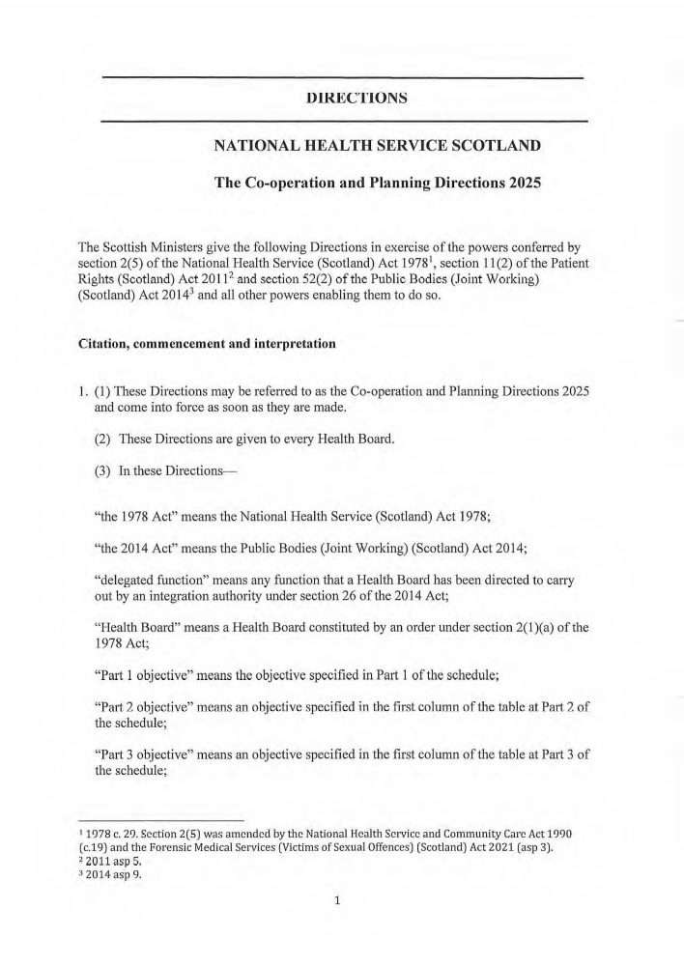

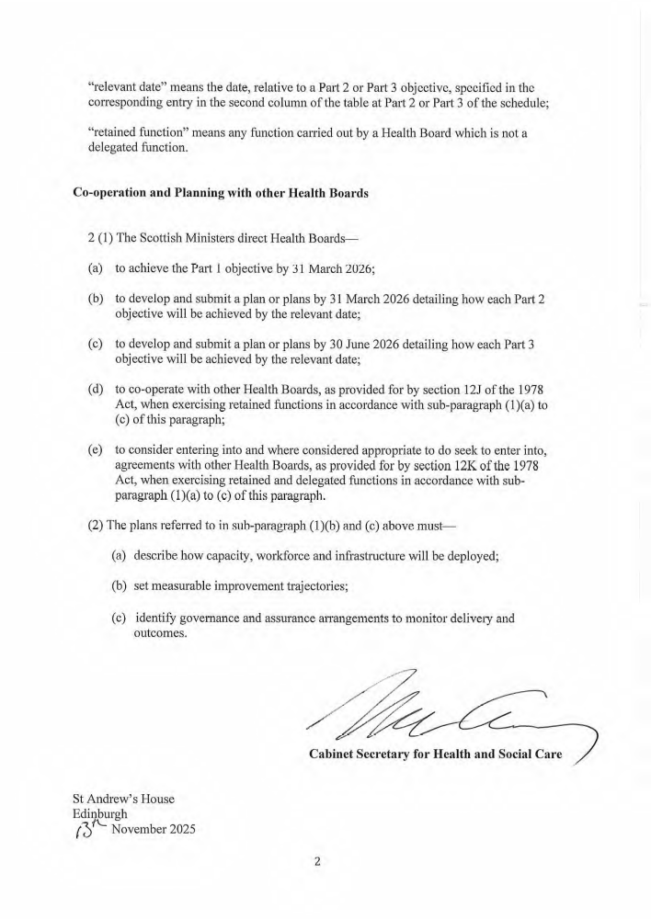

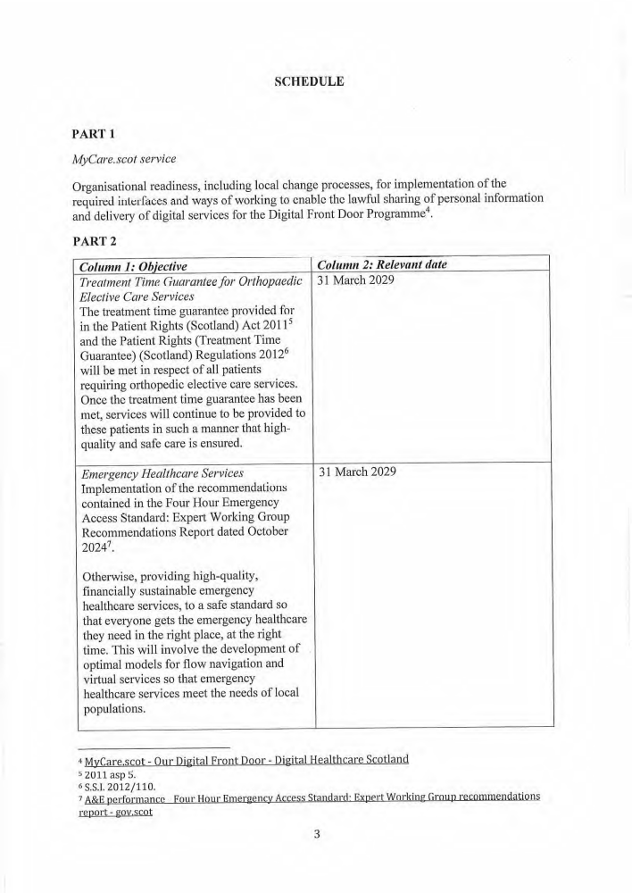

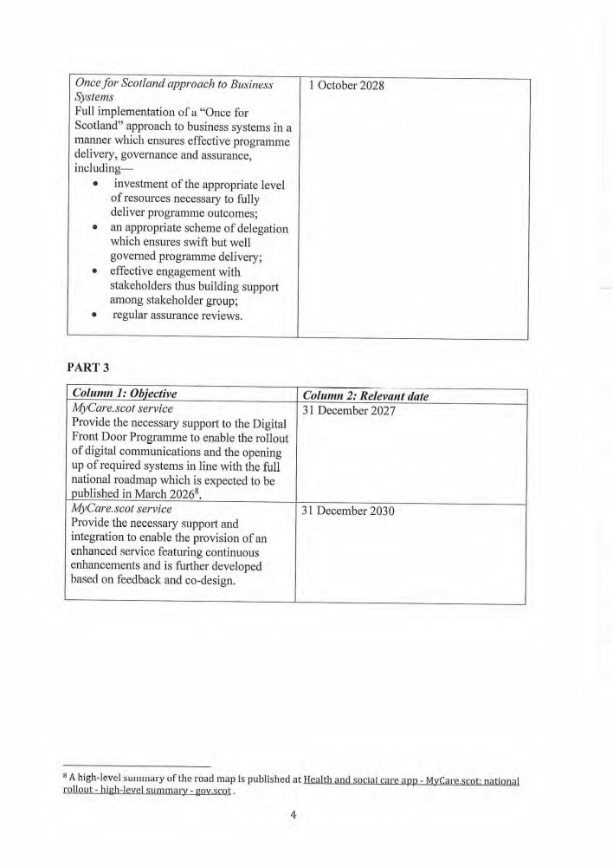

The deadline for submitting Plans for Part 2 objectives is 31 March 2026. The deadline for submitting Plans for Part 3 objectives is 30 June 2026.

